Digital System Design
Introduction
This document captures the technical details related to the DSD-Latch and Flip flops experiment development.

Project
Domain Name : Electronics and Communication
Lab Name : Digital Logic Design
Experiment Name : Latches and Flip-flops

Both Latches and flip flops are circuit elements wherein the output not only depends on the current inputs, but also depends on the previous input and outputs. The main difference between the latch and flip flop is that a flip flop has a clock signal, whereas a latch does not.

What are Latches and Flip Flops?
The definitions of the latch and flip flop is discussed below.

What is a Latch?
A latch (bistable multivibrator) is a device which has two stable states namely high output as well as low-output. This includes a feedback lane; accordingly, data can be stored with the device. A latch is a memory device used to store one bit of data. These are same like flip-flops, however, they are not synchronous devices. They do not work on edges of the clock as FFs do.
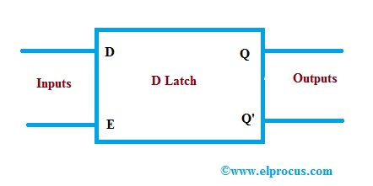

What is a Flip-Flop?
A Flip-Flop or FF is a couple of latches, and the designing of this can be done using a NOR gate or a NAND gate. Therefore, an FF can have 2-inputs, 2-outputs, a set as well as reset. This type of FF is named as SR-FF. The main function of the flip-flop is to store the binary values. A Flip-Flop will have an extra CLK signal to make it work in a different way when contrasted with a latch.
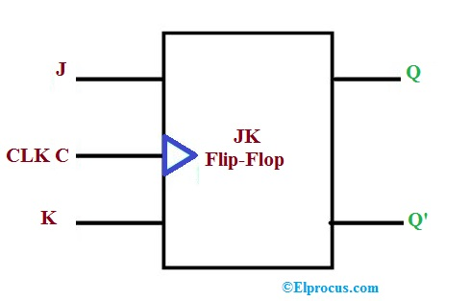

Purpose of the project
The purpose of the project is to convert the Latches and Flip-flops experiment simulation from Java applet to Javascript.

Project Developers Details
S.NO | Names | Year of Study | Role | Email-ID | github handles
1. | Shreesh | 2 | Developer | Tripathi.shreeshv@gmail.com | shreeshh

Technologies and Libraries
Technologies :
- HTML
- CSS
- Javascript
Libraries :
SimCirJs
Development Environment
OS : Ubuntu 18.04

Documents :
S.NO | Link to Document | Role
1. | Procedure | This document captures the instructions to run the simulations
2. | Test Cases | This document captures the functional test cases of the experiment simulation
3. | Code Documentation | This document captures the details related to code

Process Followed to convert the experiment
- Understand the assigned experiment Java simulation
- Understanding the experiment concept
- Re-implement the same in javascript
Value Added by our Project
- It would be beneficial for engineering students
- Highly beneficial for tier 2 and tier 3 college students who can use this to learn and understand the concept of design layout.

Risks and Challenges
Did not know javascript or digital logics before starting the project. Had to learn about both and then learned how to implement libraries such as simcirjs as well. Learned about new features in HTML like canvas.

Issues :
None known as of now.

